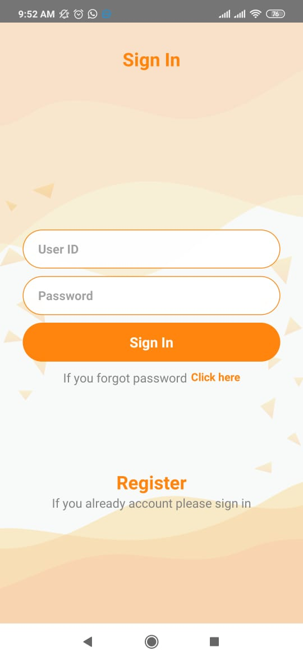

1.Login store In Session

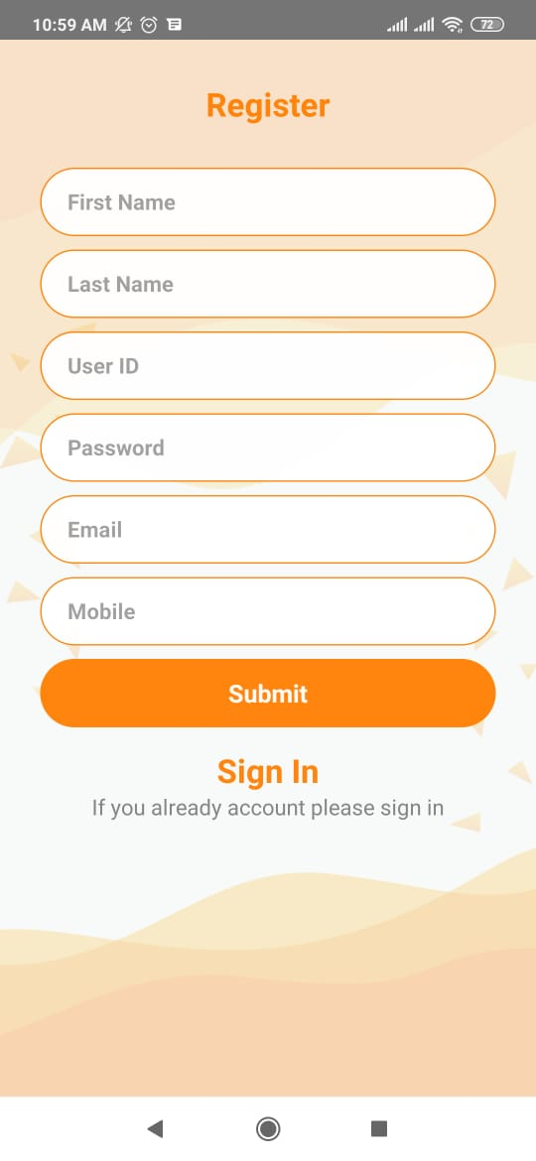

1. Valid email
2. Username must be unique
3. Password must be unique
4. Confirmation email.

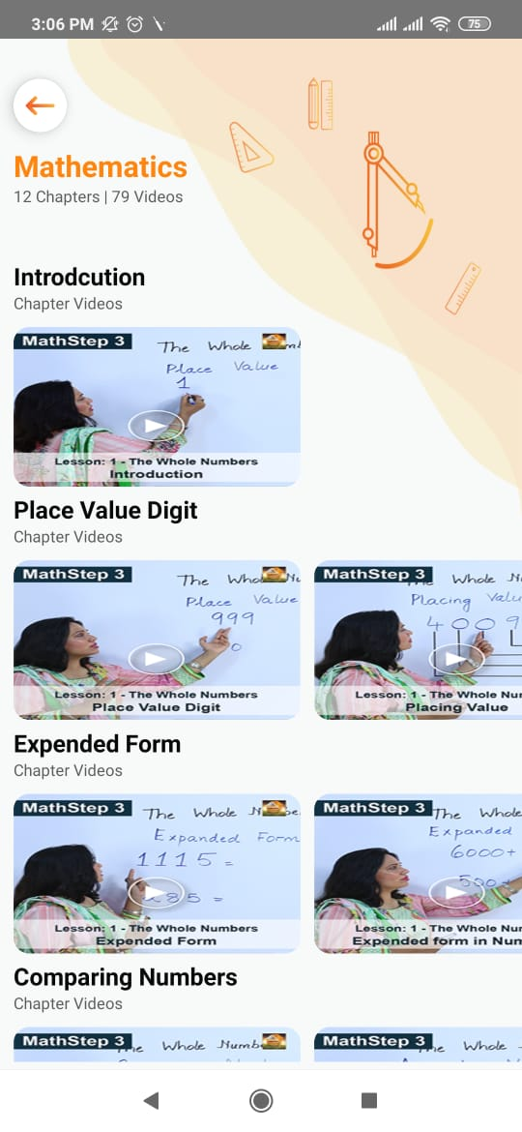

1. on scroll down video loader show

2. Videos and chapter count should be correct all pages are same count.

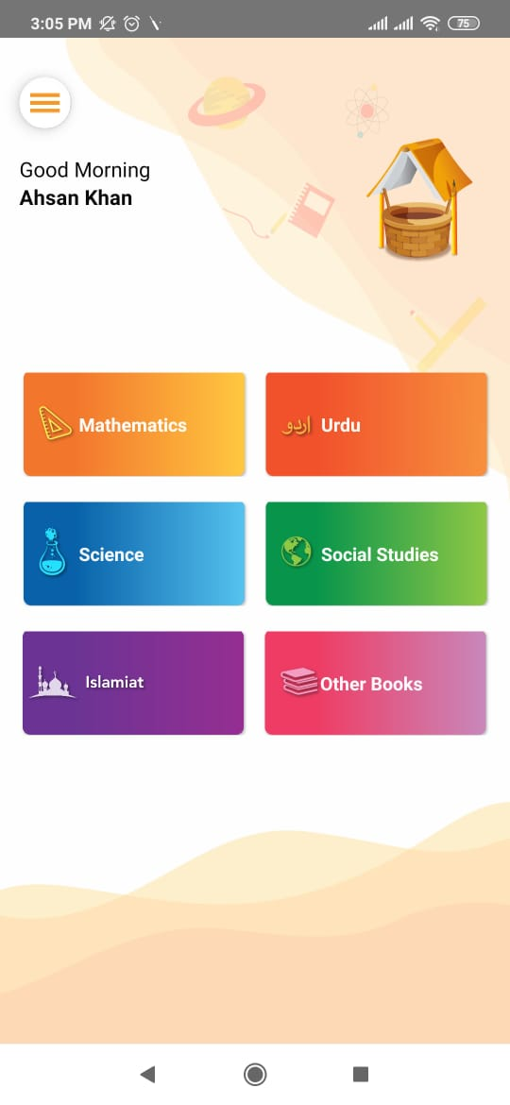

1. Change other book to English
2. Please Check all button they showing wrong videos
3. Each page show loader if video is not load
4. After click the button loader display in dashboard screen



1. Video page back button
2. Video player change

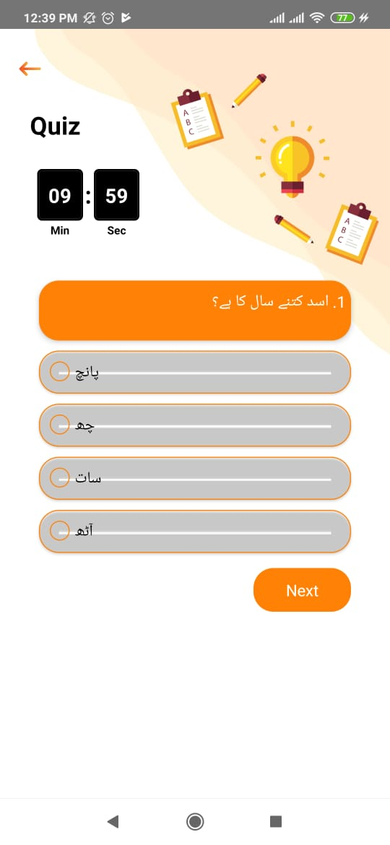

1. After quiz start don’t back
2. After competition of quiz page going on again quiz it goes to chapters page

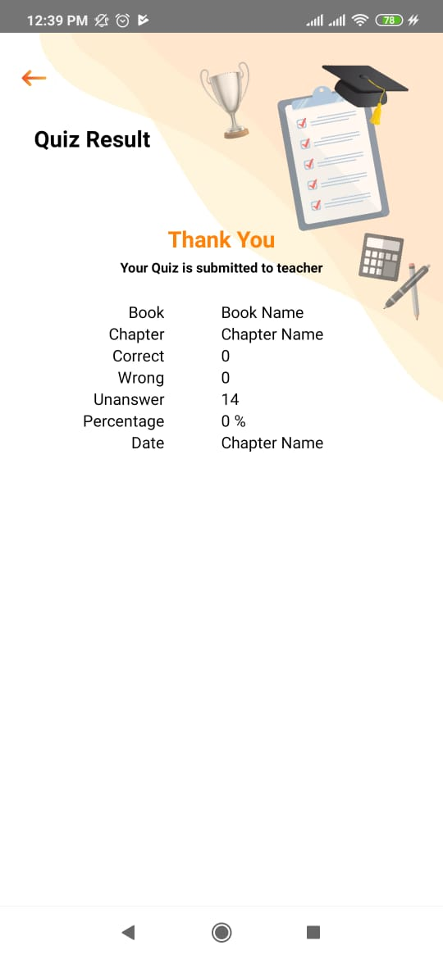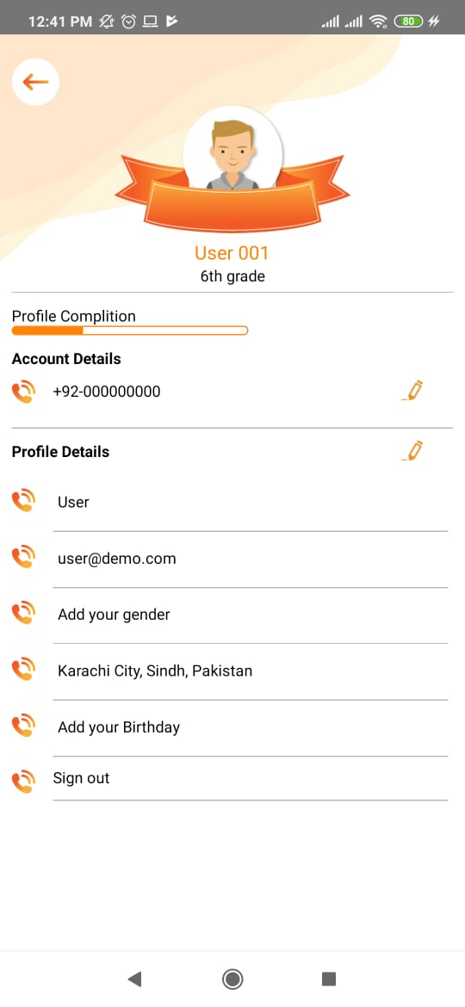

Please remove unnecessary data

Show name in ribbon

Share the app button is not working